CASA OF ARIZONA
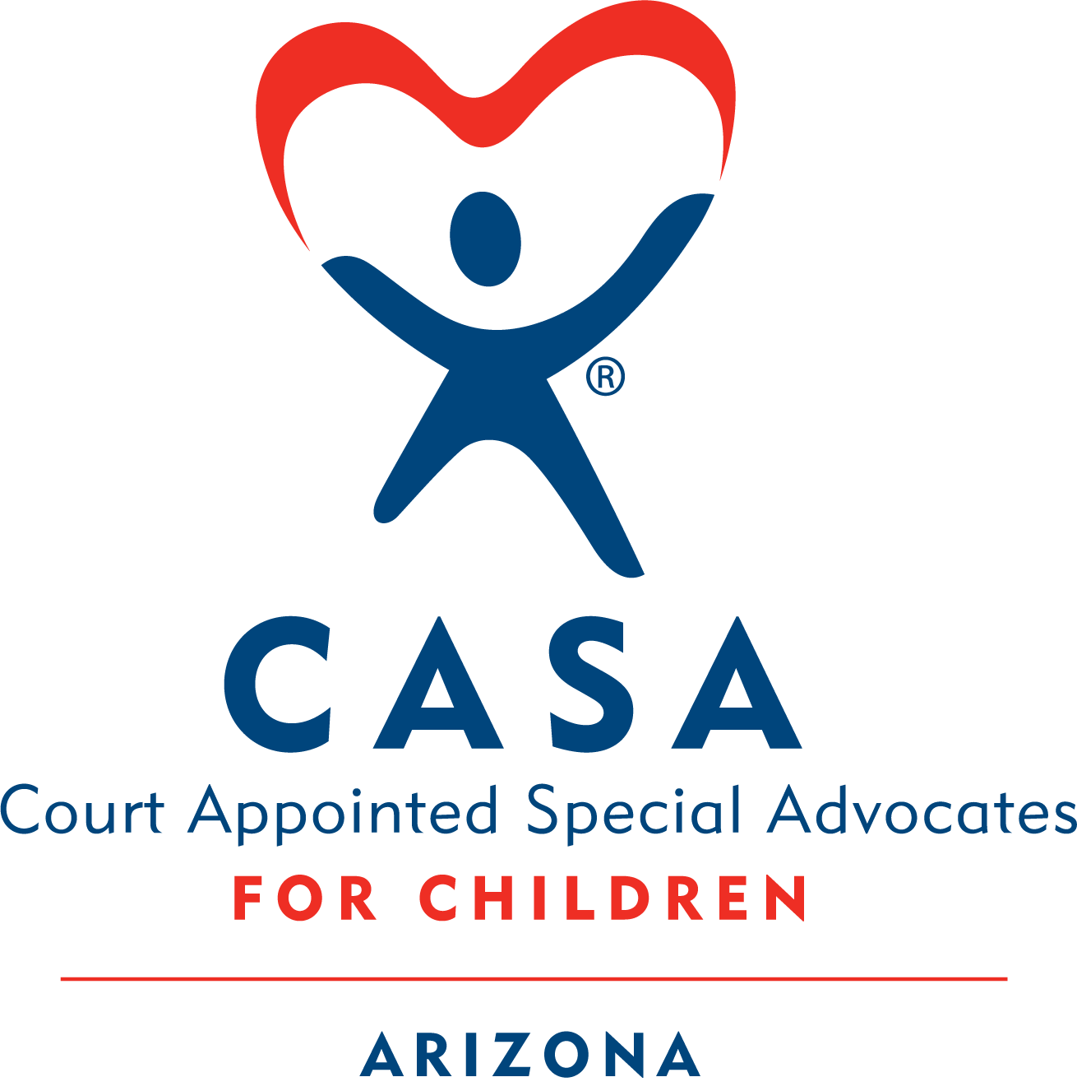

Module 3 Homework
Contents
❖ Activity 3.1 Understanding Mental Illness 2
❖ Activity 3.2 Childhood Trauma 4
❖ Activity 3.3 Adverse Childhood Experiences (ACEs) & Positive Childhood Experiences (PCEs) 7
❖ Activity 3.4 Trauma Informed Principles 8
❖ Activity 3.5 Resilience 9
❖ Activity 3.6 Obtaining Confidential Records 10
❖ Activity 3.7 Rosa Case 13

Activity 3.1 Understanding Mental Illness

Definition
“A mental illness is a condition that impacts a person’s thinking, feelings, behavior or mood. These conditions deeply impact day-to-day living and may also affect the ability to relate to others.” — National Alliance on Mental Illness (NAMI)
- Definitions may vary across cultures, time periods, and regions.
- In the U.S., diagnosis is guided by the DSM-5 (Diagnostic and Statistical Manual of Mental Disorders).
- Dual diagnosis: Having both a psychiatric disorder and a substance use disorder.

Causes
- Mental illness arises from multiple overlapping factors:
  - Genetics
  - Biology
  - Environment
  - Life stressors
- They are not caused by weakness or character flaws.
- Disorders may be:
  - Biological/neurological (e.g., brain chemistry)
  - Experiential (e.g., trauma, life experiences)
- CASA volunteers should recognize that mental illness affects the whole person: mind, body, emotions, relationships, and spirit.

Impact of Parental Mental Illness on Children
A parent experiencing mental health issues can have an impact on their child(ren), potentially leading to social, emotional or behavioral problems.
Children may experience:
- Parentification (taking on adult responsibilities)
- Self-blame for parent’s struggles
- Anger, anxiety, guilt
- Embarrassment, shame, isolation
- School problems, drug use, poor relationships
- Higher risk of mood disorders, alcoholism, personality disorders
Important: Even when abuse, neglect, or addiction is present, children often still love their parents deeply. This bond should be respected and considered in advocacy.
Resilience matters: With protective factors, family strengths, and supportive services, children can still thrive despite challenges.
Untreated Mental Illness
- Barriers: lack of appropriate & effective resources (including access & cost), stigma, misunderstanding, fear
- Consequences:
  - Isolation, despair
  - Incapacitated to the point of being unable to care for children
  - Severe symptoms (hallucinations, delusions)

Mental Illness & Child Welfare
- In child welfare cases, DCS & the Courts are focused on: Is the parent’s functioning sufficient to keep the child safe?
- They consider several factors:
  - Presence of another competent adult
  - Distinguishing mental illness from other limitations (e.g., learning disabilities)
CASA should focus less on the diagnosis and more on a parent’s ability to provide a safe home.
With treatment (therapy and/or medication), most people can function normally.

Assessment
It is not your task to diagnose mental illness. However, it is important to be aware of warning signs or indicators that may affect the health or safety of the child so that you can alert the DCS and the team about your concerns.
- Social withdrawal: isolation, dropping out of activities, decline in academic, vocational or athletic performance
- Depression: hopelessness, fatigue, appetite/sleep changes, suicidal thoughts
- Communication & thinking changes: confusion, irrational ideas, excessive fears
- Emotional expression disproportionate to circumstances: inappropriate laughter, excessive crying, hostility out of proportion to the event
- Behavior changes: hygiene decline, substance use, bizarre actions, absenteeism

Treatment
- Treatment options vary and should be personalized to individual differences.
- Common modalities include:
  - Medication treatment
  - Behavior therapy
    - Cognitive Behavioral Therapy (CBT)
    - Dialectical Behavioral Therapy (DBT)
    - Trauma-Focused CBT
  - Eye Movement Desensitization & Reprocessing (EMDR)
  - Play therapy
  - Child-Parent Psychotherapy
CASA volunteers can advocate for holistic, multimodal treatment plans that consider mental, emotional, physical, and spiritual needs — not just one dimension.

Cultural Considerations
Different cultural communities perceive mental health conditions differently. Cultural background can affect whether people seek help, what kind of help they turn to, their ways of coping, the kinds of treatment that work and the barriers to receiving effective care. It’s crucial that professionals take culture into account when evaluating mental illness and providing treatment options.

What CASA Volunteers Can Do
- Recommend assessments for parents or children, when needed.
- Request consultations or review provider documents.
- Be mindful of cultural considerations, especially when encountering barriers/opposition to treatment
- Ensure children receive age-appropriate explanations of their own or their parent’s mental health diagnoses.
- Advocate for holistic treatment (treatment that considers all aspects of an individual: mental, emotional, physical, spiritual).

Activity 3.2 Childhood Trauma

Understanding Child Trauma
What is Trauma?
Any disturbing experience that results in significant fear, helplessness, dissociation, confusion, or other disruptive feelings intense enough to have a long-lasting negative effect on a person’s attitudes, behavior, and other aspects of functioning. (APA, 2018)
Examples include:
- Witnessing domestic violence
- Experiencing physical or sexual abuse
- Death or loss of a loved one
- Automobile accidents
- Life-threatening natural disasters
Trauma overwhelms a child’s ability to cope, often leading to fear, helplessness, or horror.
Types of Trauma
Trauma can be categorized into four main types:
- Acute Trauma → A single, time-limited incident (e.g., car accident).
- Chronic Trauma → Repeated events over time (e.g., ongoing domestic violence).
- Historical Trauma → Emotional/psychological injury passed across generations (e.g., slavery, forced boarding school placement).
- Complex Trauma → Chronic trauma + lasting impact on well-being, often beginning early in life and involving caregivers (e.g., abuse by a parent).
By the time children enter child protection systems, many have experienced chronic or complex trauma — often at the hands of those entrusted to care for them.
How Trauma Affects Children
Children respond differently to trauma depending on factors such as:
- Age or developmental stage
- Perception of danger
- Whether they are a victim or a witness to the event
- Relationship to victim or perpetrator
- Past trauma experiences
- Adversities faced after the trauma
- Availability of supportive adults

Exposure to traumatic events may have long-term impacts such as:
- Behavioral challenges
- Decline in school performance
- High-risk behaviors
- Health problems
- Relationship difficulties
For children who cannot verbalize emotions, trauma may show up as physical tension or frequent health complaints.
Cultural Considerations
- Culture shapes how trauma is experienced, interpreted, and expressed.
- Families may understand trauma differently based on cultural values, traditions, and beliefs.
- Effective support requires respecting and integrating cultural perspectives into assessment and care.

Optional Reading
What is Complex Trauma - A Resource Guide for Youth and Those Who Care About Them.
📂 How to open the document:
- Double-click the PDF icon labeled “What is Complex Trauma”
- If it doesn’t open, right-click the icon, choose ‘Object’ from the menu, then click ‘Open’
- If it still isn’t working, click on this link Homework to access it through the website.

What a CASA Volunteer Can Do
Exposure to trauma can shape a child’s behavior, worldview, and sense of safety. As a CASA volunteer, your role is not to provide therapy, but to advocate with compassion and awareness.

Key Practices
- See the whole child: Treat each child as an individual, not just as a “victim.”
- Look beyond the current event: Recognize that many children have long histories of trauma, not just the incident that brought them into care.
- Recommend trauma screenings:
  - Behaviors that appear as “misconduct” or developmental delays may be trauma-related.
  - Screenings by therapists/clinicians help place behaviors in the context of lived experiences.
- Communicate regularly: Stay in touch with therapists, caseworkers, and treatment providers to better understand the child’s needs.
  - Remember: Your role is advocacy, not therapy.
- Consider parents’ trauma:
  - Many parents in the system have unresolved trauma histories.
  - Recommending screenings for parents can provide insight into their behaviors and help explain family dynamics.
Viewing both parent and child through a trauma-informed lens fosters compassion and understanding.

Refer to worksheet and answer the question.

Activity 3.3 Adverse Childhood Experiences (ACEs) & Positive Childhood Experiences (PCEs)

Part 1: Click on the link below and watch a video on the Adverse Childhood Experiences Study:
🎥 How to open the video:
- Click the link below titled “ACES Video”.
- If it doesn’t open right away, try this:
  - Hold down the “Ctrl” key on your keyboard.
  - While holding it, click the link with your mouse.
Still not working?
No problem! You can also find the video link on the homework website. Homework

ACES Video

What Are the Positive Childhood Experiences (PCEs)?
Researchers from the Johns Hopkins University defined the following PCEs and conducted a large-scale research in an adult population at Wisconsin. Seven PCEs were researched. The first three focus on the child’s family environment, and the rest focus on the child’s friends and community.
The PCEs are the following:
1. Feeling able to talk to family about feelings: A child that is able to talk about their feelings and emotions is better able to feel understood which creates a sense of belonging. This allows the child to better coregulate, deal with stress, and build their emotional intelligence.
2. Feeling that your family stood by you during difficult times: The presence of a supportive adult during difficult or stressful times can help buffer the stress for a child. Their presence and soothing words can help the child feel supported and comforted. It drives home the all-important message that the child is not alone and that their emotions are valid.
3. Feeling safe and protected by an adult at your home: Feeling safe and protected is a fundamental human need. When safety is compromised, even basic bodily functions can be affected until a sense of security is restored. Adults can help children feel safe by responding to their physical and emotional needs—whether through comforting care, talking them through overwhelming moments, or helping them co-regulate after stress.
4. Have at least 2 adults, that were not your parents, taking genuine interest in you: Children benefit deeply from having supportive adults in their lives beyond their parents—especially when their parents struggle to provide consistent safety and emotional support. Supportive adults can create moments of stability and connection, helping a child feel safe even in the midst of chaos and stress. These adults might be extended family members, neighbors, teachers, coaches, counselors, CASAs – anyone who shows up and creates space for meaningful connection in the child’s life.
5. Feeling supported by friends: Having friends you can turn to—those who listen, stand by you, share in your laughter and tears, and understand your needs—is a powerful source of support. These nurturing and dependable relationships help you weather life’s storms, offering co-regulation and emotional stability when it’s needed most.
6. Enjoying participating in community traditions: Traditions help foster a sense of belonging. They can bring people together and help a child find a sense of connectedness and purpose. Being part of a neighborhood, a school, a support group, or even having a shared hobby can bring a sense of belonging that so is important in a child’s life.
7. Feeling a sense of belonging in high school: Feeling a sense of belonging in school can help you build more resilience against adversity. Children who engage with others and in activities in school have higher rates of resilience and lower rates of chronic disease in childhood.
Adapted from: Bethel et al, Positive Childhood Experiences and Adult Mental and Relational Health In a Statewide Sample: Associations Across Adverse Childhood Experiences Levels. JAMA Pediatr. 2019; 173(11);e193007 ACEAwareNL

Activity 3.4 Trauma Informed Principles
Click the document below to read about Trauma Informed Principles:
📂 How to open the document:
- Double-click the PDF icon labeled “Trauma Informed Practices Guide”
- If it doesn’t open, right-click the icon, choose ‘Object’ from the menu, then click ‘Open’
- If it still isn’t working, click on this link Homework to access it through the website.

Refer to worksheet and answer the question.

Activity 3.5 Resilience

Part 1: Resilience

Definition (APA, 2022):
Resilience is the ability to adapt successfully to difficult or challenging life experiences. It involves mental, emotional, and behavioral flexibility in response to both internal and external demands.
- Resilience is shaped by:
  - How individuals view and engage with the world
  - The availability and quality of social supports
  - Coping strategies used
- Research shows resilience skills can be learned and practiced.
- Building resilience means reducing risk factors and strengthening protective factors.
  - Protective factors help children adapt in the face of hardship and are essential for them to grow into healthy, productive adults (Harvard Center on the Developing Child, 2015).

Click the link to watch the video on resilience:

🎥 How to open the video:
- Click the link below titled “How Resilience is Built”.
- If it doesn’t open right away, try this:
  - Hold down the “Ctrl” key on your keyboard.
  - While holding it, click the link with your mouse.
Still not working?
No problem! You can also find the video link on the homework website. Homework

How Resilience is Built

Refer to worksheet and answer the question.

Part 2: The Seven C’s of Resilience

Studies of resilient people have repeatedly identified the presence of certain
protective factors. Helping children develop some of these characteristics can significantly improve their chances for positive life outcomes.

When we face stress, we naturally develop ways to cope or prevent it in the future. With practice, these skills strengthen our resilience. Healthy coping often involves building one of the “seven Cs”:

- Competence → Knowledge, judgment, and skills to handle situations effectively
- Confidence → Belief in personal abilities; willingness to take risks to grow
- Connection → Strong ties to family, community, and a sense of belonging
- Character → Morals and values to guide choices between right and wrong
- Contribution → Feeling like a valued member of society and able to make a difference
- Coping → Skills to manage stress in healthy ways
- Control → Belief that one’s actions can influence outcomes, not just fate

Adapted from “The 7 Cs: The Essential Building Blocks of Resilience,” from Fostering Resilience.

In your CASA role, it is good to think through the 7 c’s and find ways to encourage and advocate for them in the children you are assigned. For example in the Rosa case, you may:

- Advocate for tutoring services for Jimena to help build her competence in math.
- Give genuine praise to Israel and Jimena, to help build their confidence.
- Advocate for visits with the Rosa children and their grandfather (as long as this is approved by the DCS case manager) to strengthen their connections.
- Be a good role model to the children and have conversations regarding strong morals/values as they share about their lives to help strengthen their character.
- Take Jimena to a place to volunteer, where she is able to see the difference she can make, helping her build a sense of contribution.
- Find out the coping skills Jimena is working on in counseling and offer opportunities to practice those skills in your time together.
- Advocating for Jimena to attend court hearing and CFTs, where her voice can be heard to allow for some opportunities of control.

Refer to worksheet and answer the question.

Activity 3.6 Obtaining Confidential Records
Your Order of Appointment
- When you’re appointed as a CASA volunteer, the court gives you an official document called an Order of Appointment.
- This document tells agencies and individuals that you are legally allowed to access records about the child, even if those records are normally confidential.
- Keep multiple copies with you - you’ll need to show it whenever you visit agencies, hospitals, schools, or anyone who keeps records about the child.
Child Records vs. Parent Records
- Your court order gives you broad access to the child’s records.
- Parent or adult records may be harder to get – it may be best to request those records through DCS, since they can legally obtain and share them with you.
Discovery Process
- Some information comes through a legal process called discovery - documents are gathered and sent to your local CASA office.
- Sometimes you may need to request certain records yourself.
Call Ahead for Records
- Agencies often need time to pull files, so you should call ahead and schedule a time to review them - some places let you make copies; others will mail or send them to you.
- If anyone refuses to give you access, you should contact your CASA coordinator for assistance.
Confidentiality Responsibilities
As a CASA volunteer, you will have access to sensitive, confidential information about the child and the adults involved in the case. You are legally and ethically responsible for protecting that information.
You may only share confidential information with:
- CASA program staff
- The attorney(s) assigned to the case
- The caseworker
- The court
- Anyone else only if required by law or local court rule
You may sometimes feel pressure to share information — especially right after someone shares something with you or when you think sharing might help the child. But your role is to gather information for the court, not to pass information to people who aren’t authorized to receive it. If information does need to be shared, you should work with your program coordinator to figure out how to facilitate communication without violating confidentiality.

When unsure, always talk to your CASA coordinator.

What Information Should You Share with the Child?

You’re expected to build a meaningful, trusting relationship with the child so you can make well-informed recommendations. Part of your role is ensuring the child is appropriately informed about their case — but always in a way that fits their age and developmental level. Sometimes, another team member (caseworker, therapist, etc.) may be the more appropriate person to share certain details.

The child should be informed, in an age-appropriate way, about:
  - Upcoming court hearings
  - What issues will be discussed
  - Your recommendations
  - The outcome of those issues
If you’re unsure whether something should be shared with the child, ask your coordinator.

Sharing Information with Foster Parents

CASA volunteers are not the source of case information for foster parents — that responsibility belongs to DCS and the foster parents’ licensing agency

Foster parents do need certain information to care for the child, and federal law requires DCS to provide:
- Health records
- Education records
- Updates at placement and whenever the child moves

Sometimes you may know something essential for the child’s safety or the safety of others in the home.

Example:
- A child has a history of sexual victimization and has acted out in a previous placement. The current foster parent doesn’t know this, and there is another young child in the home.

In such cases, it is clearly in the child’s best interest for the foster parent to receive this information — but you should not share it directly.

Instead:
- Discuss the situation with your CASA coordinator.
- Contact the DCS case manager.
- Clearly state that this critical information must be shared with the foster parent.

Should You Tell a Source You’ll Share Their Information?
- When introducing yourself, explain that your role includes gathering information to make recommendations to the court. People need to know from the start that what they share may be included in your report.
- You should never promise confidentiality to anyone who gives you information.

Activity 3.7 Rosa Case

Rosa Case:
So far, you’ve reviewed the Dependency Petition, the first DCS report to the court, and CASA contact logs. Now, you will read:
- A DCS Addendum Report (filed before the first Review Hearing — see “Hearing Types” in Module 2)
- The Minute Entry from the Review Hearing
- Another DCS Addendum Report (specific to Israel’s situation)
- Additional CASA contact logs

Timeline Recap:
- Children removed → January 2024
- Initial hearings → January 2024
- First Review Hearing → June 2024
- Court updated on changes with Israel → July 2024
- Next court hearing scheduled → Sept 2024

Instructions:
Click the PDF below to read the latest Rosa case documents. As you read, take notes on key information. In upcoming classes, you’ll work in groups to discuss:
- What to include in the assessment section
- What to note in the opinions & concerns section
- What recommendations you might make for this case

📂 How to open the document:
- Double-click the PDF icon labeled “Module 3 Rosa HW Documents (2)”
- If it doesn’t open, right-click the icon, choose ‘Object’ from the menu, then click ‘Open’
- If it still isn’t working, click on this link Homework to access it through the website.

Citations

American Psychiatric Association. (2022). Trauma and stressor related disorders. In the Diagnostic and statistical manual of mental health disorder (5th ed., text rev.).

